COVID Vaccines for Babies & Children: Frequently Asked Questions

*Note: COVID vaccines are now available for babies and children 6 months and up. To learn more about the latest authorization, read our* [*overview document*](https://www.dropbox.com/scl/fi/4argwovkwrxf3ons8ptnp/Under-5s-Key-Messages-External.docx?dl=0&rlkey=k0b4cgqmqengzvu0zunx3226x)*.*

**Why should I vaccinate my child against COVID?**

* COVID is a risk for young children.
  + Hospitalizations [rose sharply in young children](https://www.cdc.gov/mmwr/volumes/71/wr/mm7111e2.htm?s_cid=mm7111e2_w) during the first Omicron wave in winter 2021-22.
  + As of May 28, 2022 there have been 442 COVID deaths in children under the age of 5.
* While the risk of hospitalization and death from COVID is much lower in children than adults, children are still at risk from COVID. The global pandemic has taken the lives of millions of adults. Just because the number of adult deaths has been unimaginably high, however, does not mean the impact to children has been insignificant. Over 400 families now have empty high chairs and booster seats at their tables each morning.
* We can’t predict which children will have severe illness from a COVID infection – more than half of children who have been hospitalized don’t have any underlying medical conditions.
* We can now prevent the death of children by getting them vaccinated.
* Vaccinating children can also help keep them healthy and in school, avoiding further disruption to their routines.

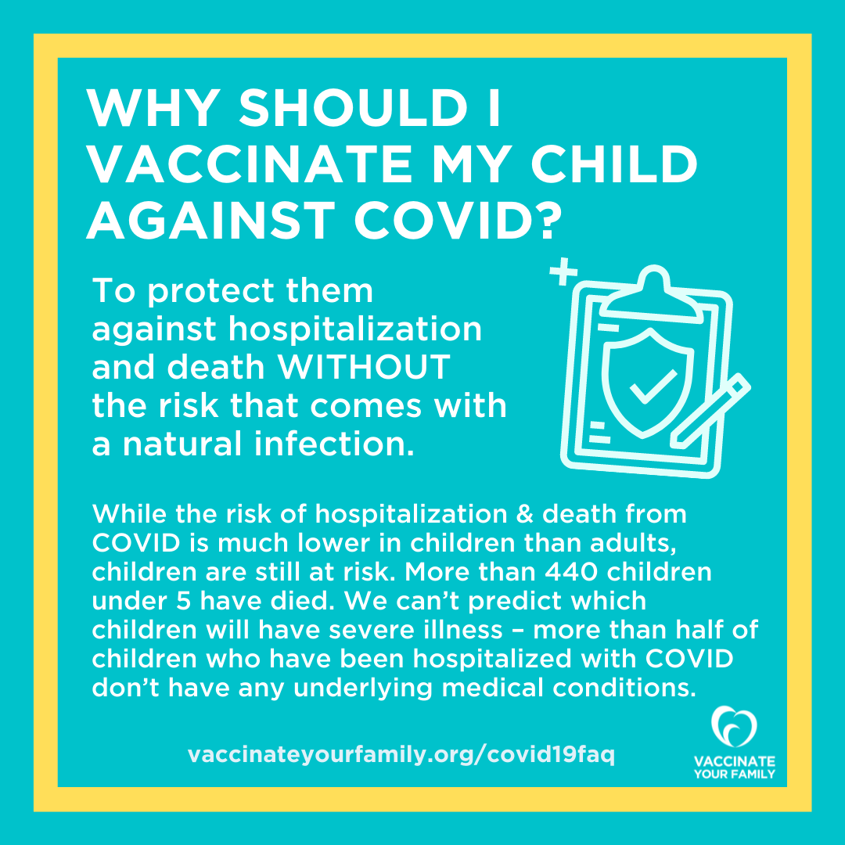

[*CLICK HERE to download a hi-res version of this graphic*](https://www.dropbox.com/s/jgafl5aw39a3pd8/U5%20-%20Why%20vaccinate%20-%20External.png?dl=0)

**Is the COVID vaccine safe for my child?**

* Yes, the COVID-19 vaccines are safe for kids under 5.
* The clinical trials included more than 9,000 babies and children under 5, and more than 10 million children ages 5-11 have been vaccinated against COVID.
* The vaccine might cause some mild to moderate, temporary reactions that are not dangerous. Children under 5 experienced pain and redness at the injection site, fever, headaches, chills, and muscle pain. These reactions mean your child’s immune system is working to protect them.
* The dosage and timing of the vaccine has been specifically developed and tested to be safe and effective in the youngest kids. The dosage is based on the maturity of your child’s immune system, not on the size of your child, which is why it is based on age and not weight.
* The risk of myocarditis and pericarditis, a very rare vaccine side effect that has been seen especially in adolescent males, appears to be very low for children under 5 (lower than for adults and adolescents). There were no cases in the trials, and experts will continue to monitor for this rare side effect in real-world use.
* We have more data on the safety of the COVID-19 vaccines than we will EVER have for most medicines, vitamins, or nutritional supplements.
* Even after vaccines are approved, safety systems are constantly monitoring for any rare side effects or safety concerns. Learn more about how we make sure vaccines are safe using a network of safety systems in this [new video from Vaccinate Your Family](https://www.dropbox.com/s/giy4gevkv6aumpe/SafetySystems-VYF.mp4?dl=0).

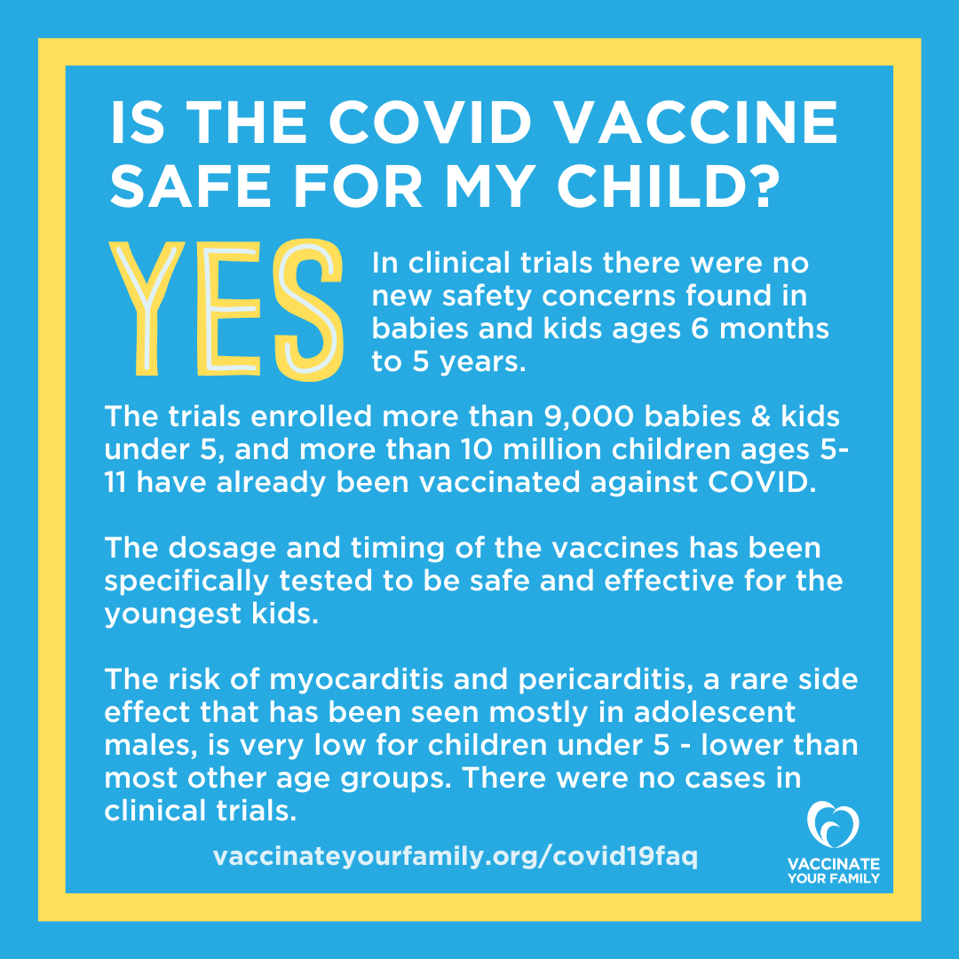

[*CLICK HERE to download a hi-res version of this graphic*](https://www.dropbox.com/s/dfjdex9p83d7adg/U5%20-%20Vaccines%20safe.png?dl=0)

**Where can I get the vaccine for my child?**

* Children under five could receive their first dose as early as June 21.
* An initial supply of 10 million doses will be available the first week with a second round of doses available the following week.
* Parents can visit vaccines.gov to view the nearest available COVID-19 vaccine options for their children. All states are ensuring they have vaccines available at public health departments in case a child does not have a personal health care provider or in the case that some providers are unable to stock the vaccine due to storage requirements.

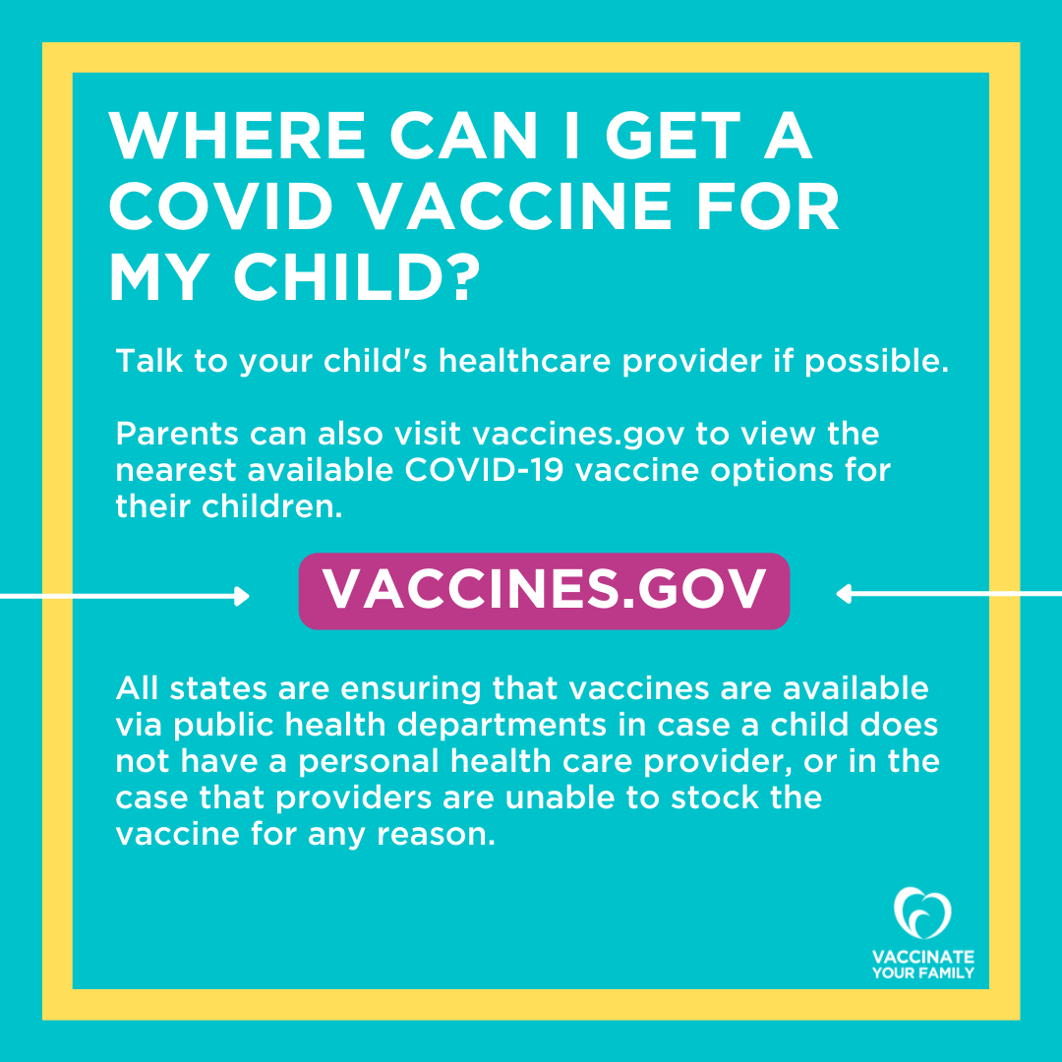

[*CLICK HERE to download a hi-res version of this graphic*](https://www.dropbox.com/s/tetjt87qfv2sm50/U5%20-%20Where%20can%20I%20get%20a%20vaccine%20-%20External.png?dl=0)

**Can my child get a COVID vaccine at the same time as other vaccines?**

* Yes, children can get the COVID vaccine at the same time as other vaccines.
* Babies and children under 5 often get more than one vaccine at a time when they visit their pediatrician. These recommended vaccines provide protection against 14 dangerous diseases – and now COVID-19 too.
* Many families missed getting routine vaccines during the pandemic, so making an appointment with your child’s healthcare provider to get the COVID-19 vaccine is a good time to get caught up on any missed vaccines, too.
* Routine wellness vaccines prevent an average of 1,913 illnesses per hour, 2,685 hospitalizations per day, and 720 early deaths per week in the United States. They are one of our most important tools for keeping our children and families healthy.

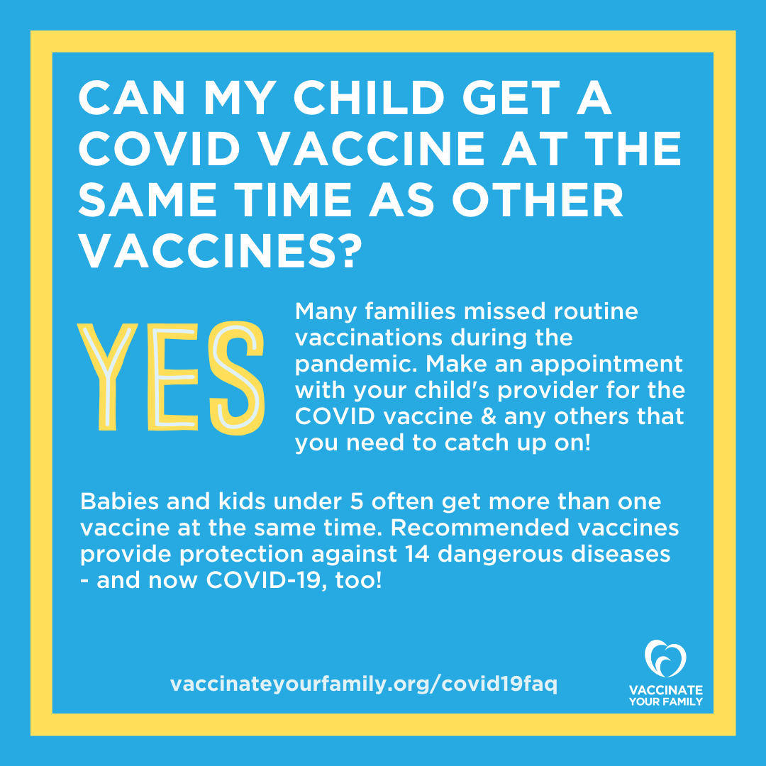

[*CLICK HERE to download a hi-res version of this graphic*](https://www.dropbox.com/s/3lt63aaswwy542z/U5%20-%20Same%20time%20as%20other%20vaccines.png?dl=0)

**Should my child get a COVID vaccine if they’ve already had COVID?**

* Yes. Prior infection does not protect as well against getting infected again, especially with the newer virus variants like Omicron.
* Getting vaccinated provides a boost in protection without the risk that comes with infection.
* If your child was infected with COVID, their next vaccine dose can be delayed 3 months from when symptoms started or when they tested positive. Talk to your care provider to make the best decision for your child.

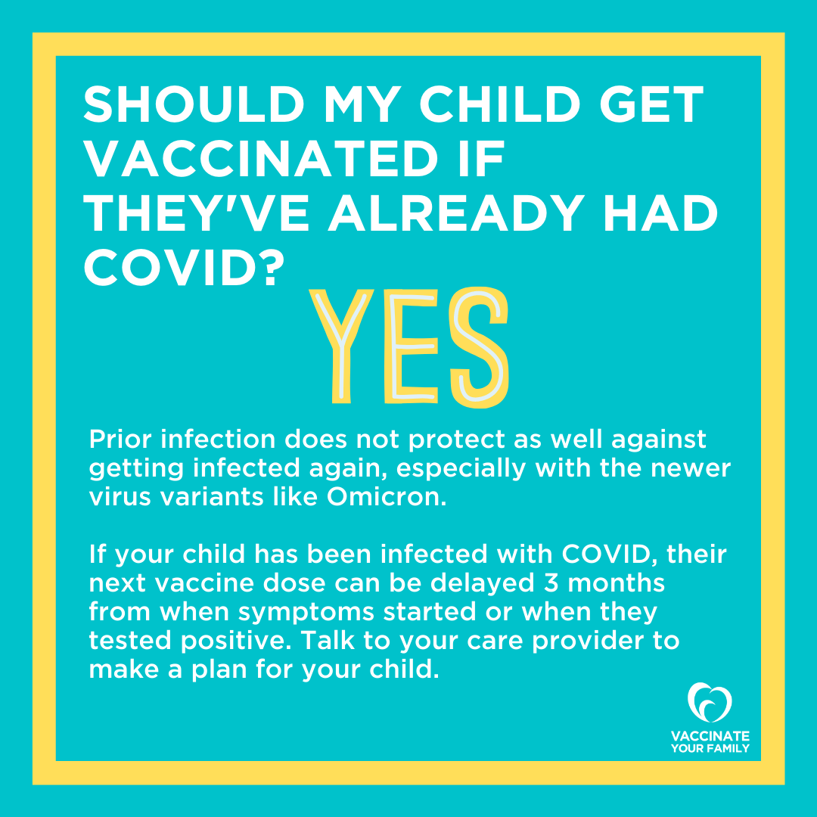

[*CLICK HERE to download a hi-res version of this graphic*](https://www.dropbox.com/s/1q25mf2oz1qx3z0/U5%20-%20Already%20had%20COVID.png?dl=0)